SQL STATUS

🔹 Purpose
# Source: AI Source: Provided by: [Data Path: Persons Table -> ID Column: 1, Name_En Column: Motasem Essam] -> From: [ChatGPT] on [6/11/2026]
These commands allow you to:
- Monitor server runtime statistics (SHOW STATUS)
Useful for database diagnostics, performance tuning, and understanding system behavior.
In MySQL, SHOW STATUS displays server status variables, which provide real-time metrics about what the server is doing. These are often used for monitoring, performance tuning, and troubleshooting.

✅ What Is STATUS in MySQL?
# Source: AI Source: Provided by: [Data Path: Persons Table -> ID Column: 1, Name_En Column: Motasem Essam] -> From: [ChatGPT] on [6/11/2026]
Status variables track what has happened since the server started or since the last reset. They do not control behavior, but report activity and resource usage.

🧠 Types of Things It Shows
# Source: AI Source: Provided by: [Data Path: Persons Table -> ID Column: 1, Name_En Column: Motasem Essam] -> From: [ChatGPT] on [6/11/2026]
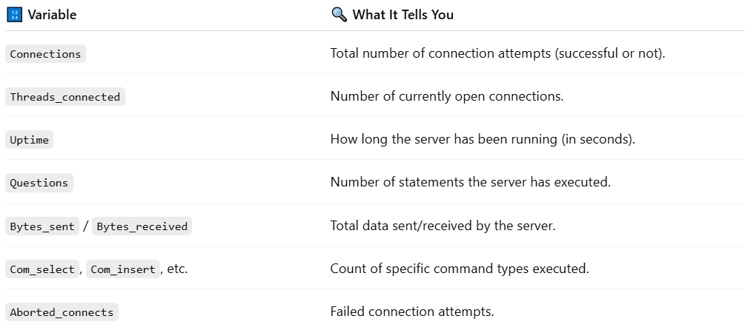
🔢 Variable | 🔍 What It Tells You
Connections | Total number of connection attempts (successful or not).
Threads_connected | Number of currently open connections.
Uptime | How long the server has been running (in seconds).
Questions | Number of statements the server has executed.
Bytes_sent / Bytes_received | Total data sent/received by the server.
Com_select, Com_insert, etc. | Count of specific command types executed.
Aborted_connects | Failed connection attempts.

🧪 Example Query
# Source: AI Source: Provided by: [Data Path: Persons Table -> ID Column: 1, Name_En Column: Motasem Essam] -> From: [ChatGPT] on [6/11/2026]
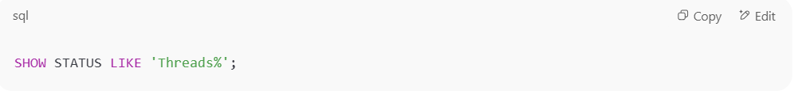
SHOW STATUS LIKE 'Threads%';

Output:
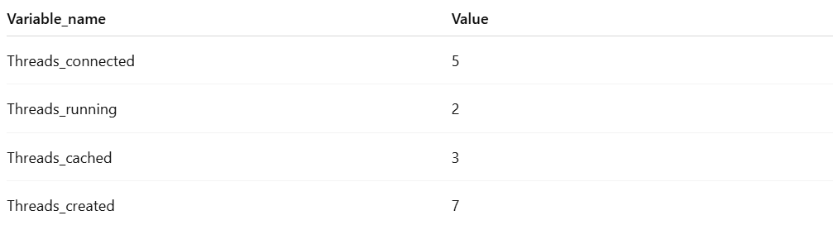
Variable_name | Value
Threads_connected | 5
Threads_running | 2
Threads_cached | 3
Threads_created | 7

🛠️ Use Cases
# Source: AI Source: Provided by: [Data Path: Persons Table -> ID Column: 1, Name_En Column: Motasem Essam] -> From: [ChatGPT] on [6/11/2026]
- 🔍 Check server load (via Threads_connected, Connections)
- ⚠️ Spot issues (e.g., high Aborted_connects)
- 📊 Track performance and throughput (Questions, Bytes_sent)
- 🔄 Use with monitoring tools like phpMyAdmin, Grafana, etc.

Let me know if you'd like a list of important status variables to monitor or how to reset them.

SHOW STATUS
✅ Syntax:
# Source: AI Source: Provided by: [Data Path: Persons Table -> ID Column: 1, Name_En Column: Motasem Essam] -> From: [ChatGPT] on [6/11/2026]
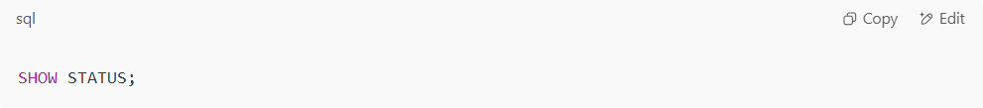
SHOW STATUS;

✅ Filter specific status:
# Source: AI Source: Provided by: [Data Path: Persons Table -> ID Column: 1, Name_En Column: Motasem Essam] -> From: [ChatGPT] on [6/11/2026]
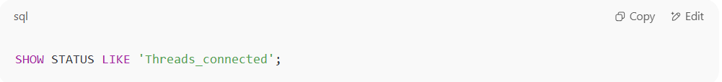
SHOW STATUS LIKE 'Threads_connected';

🔍 Example Output:
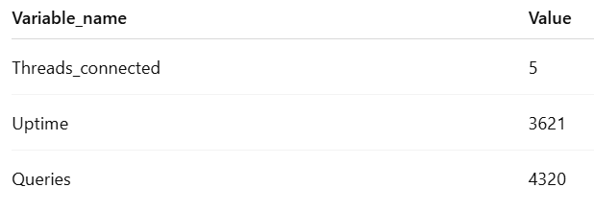
Variable_name | Value
Threads_connected | 5
Uptime | 3621
Queries | 4320

🧠 Common Use Cases
# Source: AI Source: Provided by: [Data Path: Persons Table -> ID Column: 1, Name_En Column: Motasem Essam] -> From: [ChatGPT] on [6/11/2026]
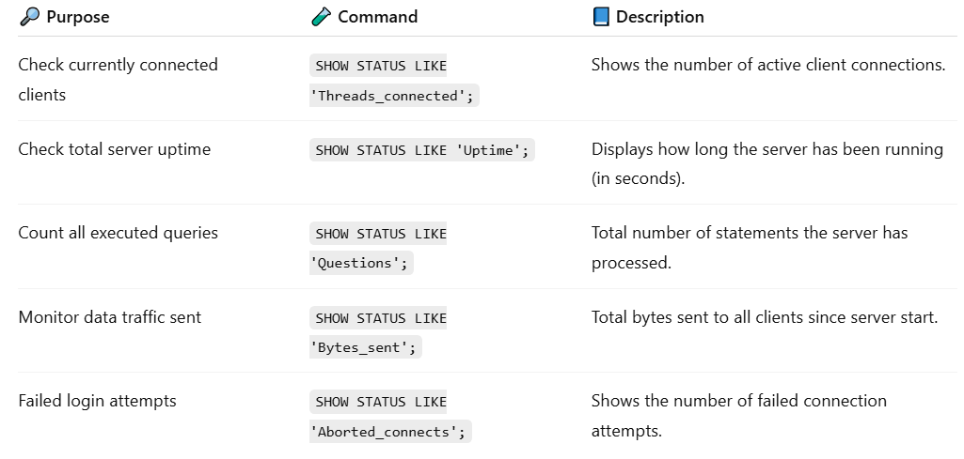

🔎 Purpose | 🧪 Command | 📘 Description
Check currently connected clients | SHOW STATUS LIKE 'Threads_connected'; | Shows the number of active client connections.
Check total server uptime | SHOW STATUS LIKE 'Uptime'; | Displays how long the server has been running (in seconds).
Count all executed queries | SHOW STATUS LIKE 'Questions'; | Total number of statements the server has processed.
Monitor data traffic sent | SHOW STATUS LIKE 'Bytes_sent'; | Total bytes sent to all clients since server start.
Failed login attempts | SHOW STATUS LIKE 'Aborted_connects'; | Shows the number of failed connection attempts.

Example

basic command
# Source: ScreenShot Source: Provided by: [Persons Table -> ID Column: 1, Name_En Column: Motasem Essam] -> Tool: [Automation Table -> ID Column: 16, Name_En Column: Screen Capture] -> From [Operating System: Wampserver64 -> phpmyadmin] on [6/11/2026]
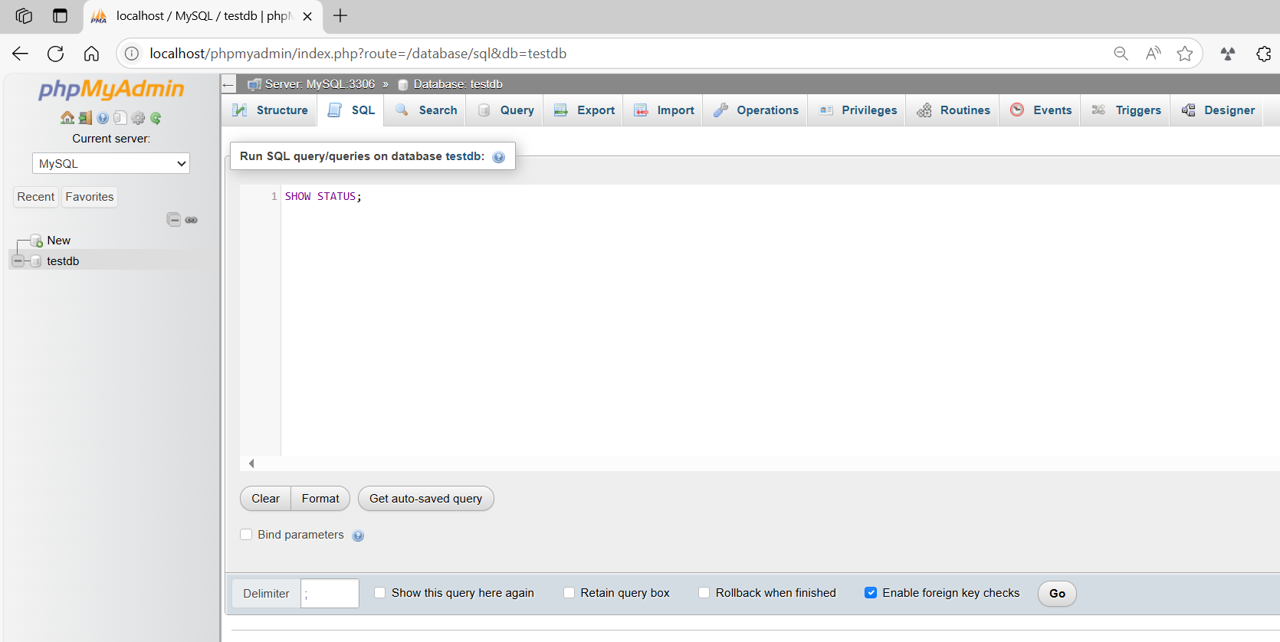
SHOW STATUS;
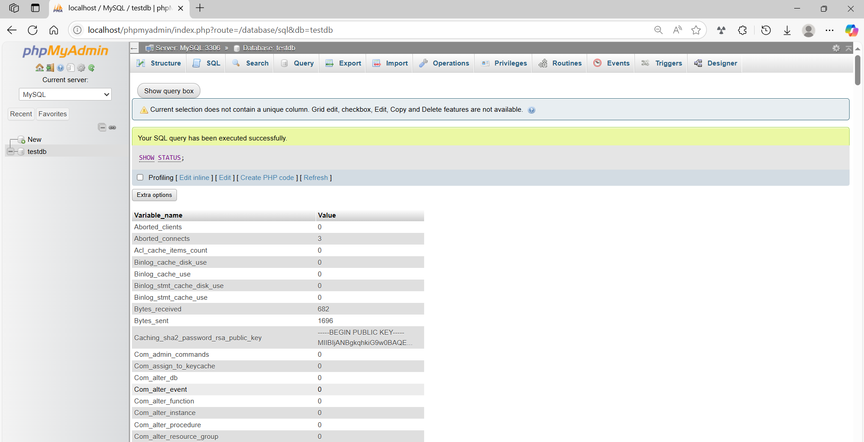

basic command
# Source: ScreenShot Source: Provided by: [Persons Table -> ID Column: 1, Name_En Column: Motasem Essam] -> Tool: [Automation Table -> ID Column: 16, Name_En Column: Screen Capture] -> From [Operating System: Wampserver64 -> phpmyadmin] on [6/11/2026]
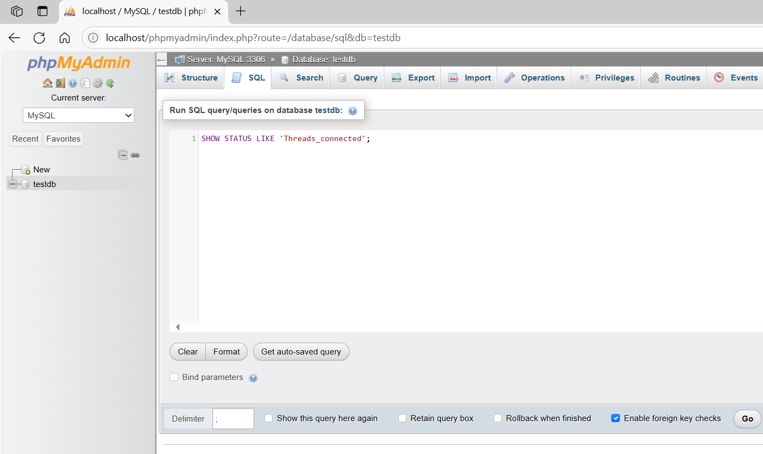
SHOW STATUS LIKE 'Threads_connected';
